LDD

The Awakening
Table of Contents
Table of Figures 1
Level Overview 1
Level Placement in the Game 1
New Enemies/Mechanics 2
Anglerfish 2
Level Map 2
Level Flow 4

Table of Figures
Figure 1 Map Legend 2
Figure 2 Map 3
Figure 3 Annotated Map 4

Level Overview
The crew has managed toe scape from the confines of what turned out to be a giant alien ship, and luckily with the alien creature intact. They must now begin the harrowing process of returning back to the surface through the dark caves. Though the aliens are still after them, and the caves don’t seem to be as quiet as they once were…

Level Placement in the Game
This is the 4th level. The player is assumed to know all the basic mechanics and controls by this point. The player is also assumed to have banked up some amount of resources from the previous levels that they can use.
This level is early-mid game. The player is still being trained somewhat on the use of sonar and the way navigation occurs in this game. This level also makes greater use of darkness than the previous levels have, to continue to force the player to interact with the sonar system.
As opposed to later levels, this level is intentionally very linear. The level introduces the darkness mechanic much more to players so this is intended to help train them on how to navigate through darkness and how to act inside of darkness. The previous levels inside the alien ship were much more lit than this, so a transition and practice level is needed.

New Enemies/Mechanics

Anglerfish
The anglerfish is introduced in this level. It is tutorialized in section 3 and used throughout the level.

Level Map
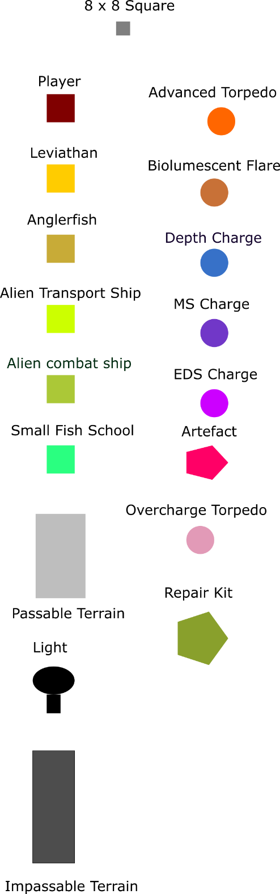
Figure 1 Map Legend
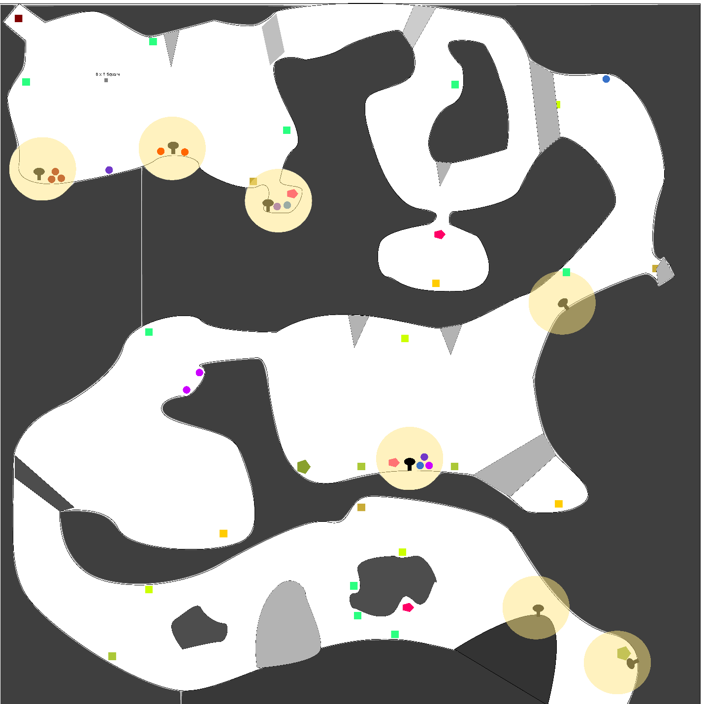
Figure 2 Map
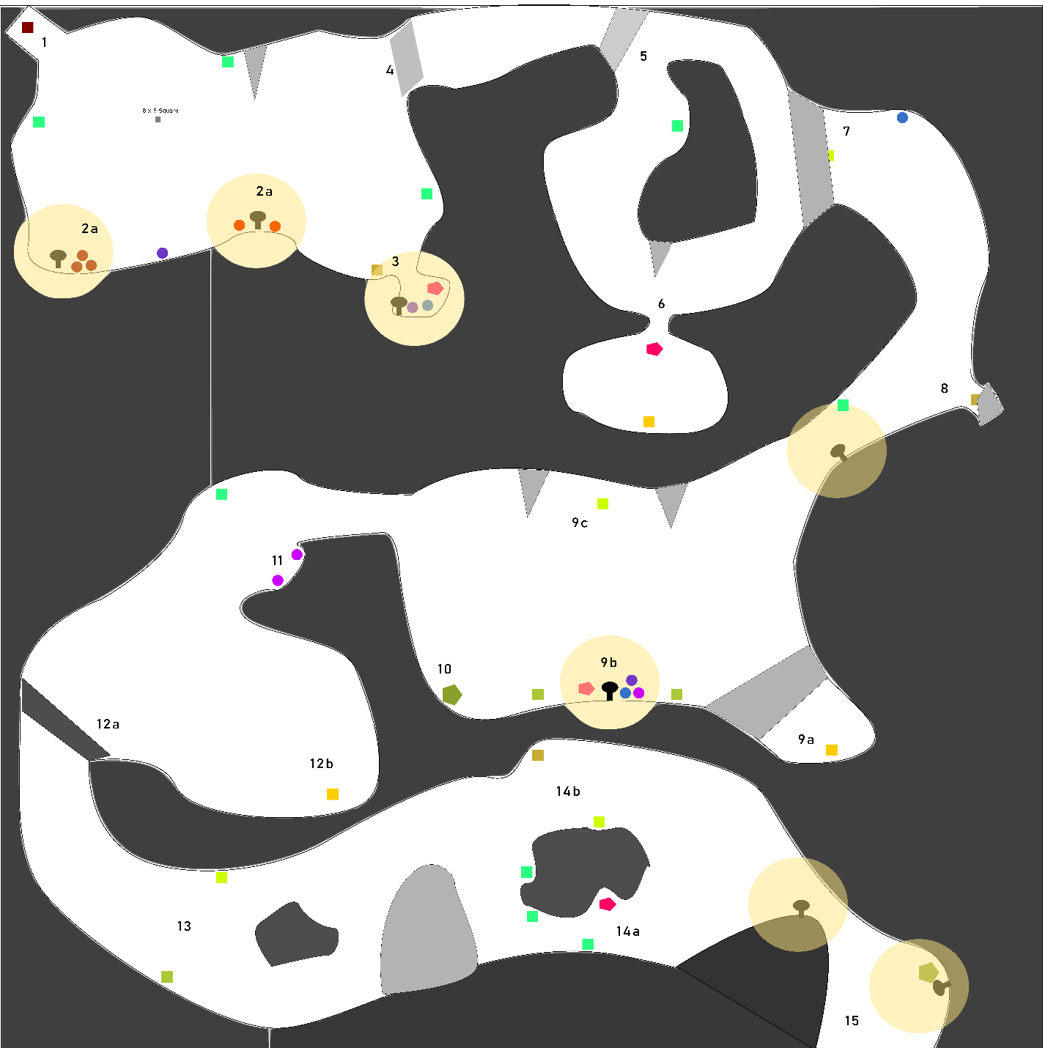
Figure 3 Annotated Map

Level Flow
Number | Description | Design Goals | Recommended Items | How Tense?
1 | The player’s starting area | This gives the player a safe area where the can decompress from the previous level. It also allows them to get their bearings before moving on. This whole area contains lots of lights and only an anglerfish as a dangerous enemy. | Any | Safe
2a | Item Resupply | These areas give the player some items to utilize and resupply a little bit after the previous level. They are shown in light to draw the player’s attention to them. 1 MS Charge is hidden in the darkness though to reward explorative and careful players. | Any | Safe
3 | Angler Ambush | Players are able to just barely get a hint of what is guarding these valuable items: an anglerfish. This gives the player an opportunity to think about how to handle the situation and a safer environment to test out what to do with anglerfish. The light is specifically placed to allow the player to barely see the anglerfish. There is also a nearby school of small fish. The player can lure the angler to these fish to see it chase them down. The tension here comes from an unknown creature and what its abilities are. | Torpedoes, Flares | Tense
4 | Progression Pathway | This pathway is purposefully unlit. The player will need to get more used to navigating with sonar as they play throughout the game, and this pathway forces the player to utilize sonar to help find it. There is purposefully only one way out to force the player to look for this opening with sonar. They could find it using light, but they are unlikely to do so as they should by this point know that light attracts predators. | Sonar, Listening Post | Tense
5 | The first fork | The player comes upon the first fork in the path. This provides a tense moment of decision making for the player. Which direction is the right choice to make? They don’t even know what the two paths will look like, much less what might be inside them. The leviathan at point 6 is also making noise the player can hear, but again, they have no idea where the sound is coming from yet adding to the tension. | Sonar, Listening Post | Tense
6 | An optional artefact guarded by a leviathan | This artefact is guarded by a leviathan. The leviathan is not actually able to get out of the small cave it is trapped in, but in order to get the artefact the player must reach their salvage arm down into the cave. This would awaken the leviathan and make it aggressive towards the player. While the player approaches this area the sound of the leviathan only grows, and due to the limitations of how much of the screen the player can see, they still can’t see the source of the leviathan’s sounds. | Airlock, Sonar, Floodlights | Harrowing
7 | A hidden transport ship | This transport is waiting for the player to pass by so it can digistruct some drones onto the player’s submersible. Player’s using sonar will be able to easily discover this ship and take it out from a safe distance, while players relying on light will be surprised and caught off guard. This serves to help reinforce the idea that sonar is the most useful form of navigation.  If a player does notice the transport ship early it serves to give the player a triumphant moment before they begin moving towards the next tense cave section.  A depth charge is hidden off to the side for explorative players to find and use later. | Sonar, Floodlights, Torpedoes | Tense or Empowering
8 | Angler Ambush and entering the trap | This angler ambush is very easy to avoid, especially if you see it coming with sonar. It is not intended to be damaging the player, but instead to help teach them about the mechanics of anglerfish, and to provide a tense moment of stealth. The player can sneak by the angler if they stay towards the opposite edge of the cavern and keep the engine on a low power mode. (Like creeping by a sleeping killer.)  Conversely the player could attempt to kill it with torpedoes, though this isn’t a recommended strategy as it will be difficult for the player to attempt to outmaneuver it in this tight space. | Sonar, Engine | Tense
9a | A sleeping leviathan | This leviathan is placed so that it will notice the loud sounds coming from combat in the trap. If it does hear these it will awaken and begin moving towards the source of the sound. The player will have to escape if the leviathan wakes up so a stealthier approach is recommended here. | Engine | Harrowing
9b | The trap’s bait | This light shows four valuable items the player wants. An artefact, and some very useful weaponry. However, two Alien Combat Ships are waiting in the darkness, and an Alien Transport Waits above. All 3 are waiting so their lights are not visible, but they will be visible to sonar. The two Combat Ships are extra dangerous because they can alert the nearby the leviathan to the player’s presence. The approach strategies for this encounter are provided in 9c. | Torpedoes, Sonar, Airlock | Tense
9c | The hanging stone spikes and the alien transport | These spikes provide a secondary way of dispatching the Combat ships below. If dislodged by torpedoes they will fall and crush the two combat ships. However, this will definitely alert the nearby leviathan, so the player would have to run off and hide to wait for the leviathan to return to its sleeping state to safely retrieve the loot. The leviathan does not fit through either the entrance or the exit of this cave.  The alien transport resides up here and if the player is not careful with their sonar it will notice the player and begin assaulting the submersible. | Torpedoes, Sonar, Listening Post | Tense
10 | A repair kit | A repair kit is sitting here in the darkness. Explorative players can find it and use it to repair some damage to their ship. | Floodlights, Sonar | Tense
11 | Extra EDS Charges | 2 EDS Charges are placed here to assist with the coming chase sequence from the leviathan. This will make the initial escape from the leviathan much easier. The leviathan will definitely be making enough sound to be heard here, so players will be very cautious, but using the salvage arm will not alert it. | Floodlights | Tense
12a | Destroying the blockage | This blockage must be destroyed in order to progress. However, once destroyed, the nearby leviathan will awaken and begin to chase the player down. This begins the final sequence of this level, the chase.  As the chase begins the player is in a very disadvantageous position: they must turn around multiple times to navigate through this awkward space. The 2 EDS Charges will be very useful here for throwing the Leviathan off the player. This forced difficulty should make the player very scared of this leviathan (akin to how resident evil does so) and the player will want to run away as fast as possible. The player also can’t always be outrunning the leviathan as they must overclock the engine to do that, so they will have to cleverly use their weapons to stave it off. | Torpedoes, Floodlights | Harrowing
12b | The sleeping leviathan | This leviathan rests here and will be awakened by the destruction of the blockage in 12a. | N/A | Harrowing
13 | Alien Combat and Transport ambush | 2 ships were alerted by the destruction and moved into this cave to find out what is going on. The alien Transport is the more dangerous one. It is intended to be harassing the player with drones while they are attempting to run away from the leviathan. Depth Charges and MS Charges can give the player some time to dispatch the drones and quickly escape.  The combat ship is intended to help distract the leviathan from the player to give the player a momentary reprieve and some extra time to dispatch the drones. | Overcharge Torpedo,  Depth Charge | Harrowing
14a | The safe path | Many bioluminescent fish line this path. With quick thinking the player may assume the lower path to be dangerous and completely avoid opting to go up instead. However there is no danger along this path and an artefact is even hidden down here. | Airlock, Floodlights, Sonar, Listening Post | Harrowing
14b | The dangerous path | This path is more open but another alien transport and an anglerfish lie in wait here. The anglerfish is intended to also distract the leviathan while the transport ship digistructs drones onto the submersible.  A player making good use of sonar should be able to find these enemies lying in wait and choose the safer, lower path. | Sonar, Listening Post, Torpedoes | Harrowing
15 | The exit and safety | The level’s exit is clearly denoted by some lights to help the player a sense of hope. A feeling “I just need to make it a little further!”. Once through the gap the player is safe, the leviathan cannot fit through there. A repair kit is here to prepare the player for the next level. | Sonar, Listening Post | Calm

The level is intended to take approximately 10 minutes to complete, assuming the player makes no mistakes.

