General Notes
These active skills are all unlocked at level 71 and new runes are unlocked in this pattern: 73, 75, 76, 78, and 80.

Barbarian

Blood Boil

Spell Type
Tactics

Cost
30 Fury

Cooldown
None

Effect
Blood Boil grants the Barbarian 25% increased attack speed for 10 seconds. This effect is extended by damaging an enemy and can be extended indefinitely. Does not count as a shout.

Runes
- Backlash
  - Blood Boil now also grants 30% increased damage while active but causes the barbarian to take 20% increased non-physical damage.
- Inhuman Force
  - Blood Boil no longer grants attack speed but now grants a 10% chance to stun on hit.
- Heroism
  - Blood Boil now grants 15% attack speed to all nearby allies as well as all other effects (including pets)
- Frenzied Strength
  - Blood Boil now grants an additional 2% attack speed per enemy within 25 yards, up to 50%.
- Drink their Blood
  - Blood Boil now also grants 12,350 life per hit to all party members.
    - This number is approximated based on other life per hit skills at level 70.
    - It is lower because the skill is also granting 25% attack speed.

Design Intentions/Goals
Blood Boil is intended to give the Barbarian another way to throw themselves into the fray and bash enemies into submission. Barbarians are forces of nature and human will, this skill is intended to fit with that aesthetic.
Blood Boil will help enable Frenzy focused builds to gain an increase of power and come closer to the attack speed cap, while other basic ability builds can be similarly improved. These builds will likely want to make use of the Frenzied Assault rune as they can easily focus down elite mobs in a GR. The nearby other mobs will be granting even more attack speed to the player to allow for these builds to focus on what they’re best at: focusing single targets.
The backlash rune combos nicely with the Superstition passive as they will cancel out to equal 0% increased damage, but that means giving up a passive skill slot.
It also provides a new type of buff for ZDPS barbarian builds to make use of. The improved attack speed for all nearby allies (including pets) can enable the other classes such as the witch doctor and necromancer to try new builds for group play.

Witch Doctor

Shambling Horror

Spell Type
Voodoo

Cost
200 mana

Cooldown
None

Damage Type
Poison

Effect
Creates a large pet that attacks enemies from a range. Its attacks damage enemies in a 10 yd radius around the targeted enemy for 400% of weapon damage as poison. The Shambling lasts until death.

Runes
- Poisonous Cloud
  - The Spirit’s attacks leave behind a poisonous cloud that slows enemies by 60% This cloud has a range of 10 yards.
- Parasitic Maggots
  - Damaged enemies take 5% increased damage for 5 seconds. This effect stacks up to 5 times. Element changes to physical.
- Toxic Vomit
  - The Spirit’s attacks no longer damage enemies in an AoE but its damage is instead increased to 700%.
- Strength of Many
  - The Spirit gains 2% attack speed for each active pet up to a maximum of 30%.
- Call of the Jungle
  - All active pets gain 25% increased damage and 10% attack speed. Element changes to physical.

Design Intentions/Goals
The Shambling Horror is a powerful pet the Witch doctor can summon similar to the Gargantuan. It deals a lot of damage but can also provide buffs or space control depending on the selected rune. The skill will help focus in on the Witch Doctor’s use of pets and fetishes to kill demons. The skill is also intended to avoid feeling like a commander to help differentiate the Witch Doctor from the Necromancer.
The Parasitic Maggots and Call of the Jungle runes are both supportive, buffing runes. They provide utility for players by increasing the damage enemies will take, by either giving a flat damage increase that any skill can take advantage of, or by increasing the damage pets deal. This means the skill can be used in tandem with Zunimassas or Helltooth for a 25% damage increase, or with other sets and playstyles for a 15% damage increase. Since damage for pets can be difficult to come by the Call of the Jungle can give a lot of value to the Witch Doctor.
Strength of the Many and Toxic Vomit are intended to be choices if the player wants to focus on Shambling Spirit as a damage dealing spell. Strength of the many combos nicely with Zunimassas, as the player would almost always have 15 fetishes, allowing for the maximum attack speed increase, and Toxic Vomit can allow players to have a solid choice for single target damage if needed.

Crusader

Zealot’s Fury

Spell Type
Utility

Cost
25 Wrath

Cooldown
10 seconds

Damage Type
Holy

Effect
Damages all enemies in a 120 degree arc in front of the player. Enemies within a 30 degree arc from the player’s center take 330% weapon damage, and damage falls off to 150% weapon damage at the edges.

Runes
- Strength of the Just
  - Increases the Crusader’s damage by 2% per enemy hit in the main cone. Lasts for 15 seconds. Maximum increase of 50%.
- Confidence from Fear
  - Increases the Crusader’s armor by 5% per enemy hit and block chance by 1% per enemy hit by the main cone. Lasts for 15 seconds. Maximum increase of 50% for armor and 20% for block chance.
- Greater Arc
  - Increases the main cone to 45 degrees.
- Wrath of the Vengeful
  - Increase the main cone’s damage to 500% of weapon damage, and the minimum falloff to 225% of weapon damage.
- Unrelenting Zealotry
  - Zealot’s Fury’s cooldown is reset if at least 7 enemies are hit by the main cone.

Design Intentions/Goals
Zealot’s Fury is a multi-purpose skill. It can provide a damage buff, an armor buff, or it can be used as a damage dealing skill in lieu of the crusader’s other skills. The skill has both a cost and a cooldown to allow it to trigger resource-spending effects (for things like Obsidian Ring of the Zodiac) and prevent it from being too easily spammable with Unrelenting Zealotry.
Strength of the Just and Confidence from Fear are both intended to allow Zealot’s Fury to fill a void on many crusader builds. The crusader lacks a solid damage buff outside of Akarat’s Champion and Laws of Valor (and laws of valor is kinda specific since it only increases attack speed), and this is also intended to provide an option for the player besides Iron Skin for a damage reduction buff.
Greater Arc is a simple rune but exists so that a legendary affix can provide this rune all the time if players want to give up an item slot for it.
Wrath of the Vengeful and Unrelenting Zealotry are damage runes for the player to use. Wrath of the Vengeful is a straightforward damage increasing rune, but Unrelenting Zealotry provides skilled players a way to get even more damage out of the skill than Wrath of the Vengeful can provide. Though this rune is totally ineffective if there is not a group of enemies to fight. Unrelenting Zealotry will be decent at greater rifting but will be much better for speedfarming nephalem rifts and doing bounties.

Demon Hunter

Target Dummy

Spell Type
Defensive

Cost
10 Discipline

Cooldown
15 Seconds

Damage Type
Physical

Effect
Summons a Target Dummy that taunts all Ranged enemies within 40 yards. This taunt lasts until the dummy dies and the dummy’s duration is indefinite if not killed. The dummy has double the Demon Hunter’s health. Only one dummy can be active at a time, so if a new one is summoned the old one is killed. (This means the Ordnance rune is triggered if that rune is applied).

Runes
- Close-combat Training
  - Taunts melee enemies but no longer taunts ranged enemies.
- Extra Padding
  - Gains 50% of the Demon Hunter’s Toughness
- Rogueish Charm
  - The dummy now charms an enemy the first time the enemy strikes it. The charm lasts for 8 seconds.
- Ordnance
  - Explodes into 5 grenades on death. Each grenade deals 1250% weapon damage as fire. Element changes to fire.
- Engineered Destruction
  - No longer taunts enemies and cannot be damaged. The Dummy instead will mimic the casts of abilities from the devices tree. Lasts 5 seconds.

Design Intentions/Goals
This skill gives Demon Hunter’s another form of defensive utility. Instead of mobility skills vault and smokescreen or buff skills like Shadow Power and Vengeance’s rune Dark Heart, this skill gives Demon Hunters a way to pull enemies off themselves. While it does have a persistent taunt effect many spells and elite affixes aren’t affected by this as they target random locations. Ranged enemies can still be dangerous even while taunted.
Close-Combat Training swaps the taunt on the skill. This allows the Demon Hunter to customize what type of enemy they will be controlling during combat. This rune also combos nicely with items like Blackfeather and Cloak of Deception allowing players to keep the more dangerous melee enemies off themselves and get more value out of the items. This rune can also give more potential damage reduction for skilled players as most damaging ranged attacks can be dodged.
Extra Padding is a generic toughness increase for the Dummy. This means it can stick around and keep the taunt up for significantly longer.
Rogueish charms is a different kind of ‘damage reduction’ for the dummy. Each enemy will be charmed after hitting the dummy once. This does mean that the dummy will take the damage and effects of that attack, but it will take longer to burst down. These two runes give the player a choice between generic damage reduction and burst prevention.
The ordnance rune is fairly self-explanatory. On death 5 grenades pop out dealing a lot of total damage (6250% total damage.). Since it drops grenades this rune can fit into grenade builds and combos with the Hellcat Waistguard. This rune can compete with the Anathema rune on Rain of Vengeance in grenade builds.
The final rune, Engineered Destruction, completely changes this skill from defense, to offense. It specifically duplicates only spells from the Devices tree to help enable new builds for Demon Hunters. Instead of focusing on frequently buffed set skills like multishot or impale, Demon Hunters can create builds around Fan of Knives or Spike Trap. It does duplicate casts of sentry, though since there is a cap on the number of active sentries there’s basically no reason to use this skill in a Marauder’s set build. It will also duplicate the effects of Vengeance. Things like the side cannons or rockets from Vengeance will be doubled, but runes like Dark Heart don’t provide any effect. 50% damage reduction on a thing that can’t even take damage doesn’t matter.

Wizard

Roiling Power

Spell Type
Secondary

Cost
30 Arcane Power

Cooldown
None

Damage Type
Fire

Effect
Creates 4 wells of power in a diamond pattern 25 yards away from the player’s current location. Each well spawn 1 spinning wheel of fire that moves to the opposite well dealing to enemies it passes through. Each wheel deals 140% weapon damage and disappears when it reaches the opposite well.
The spell looks like this:
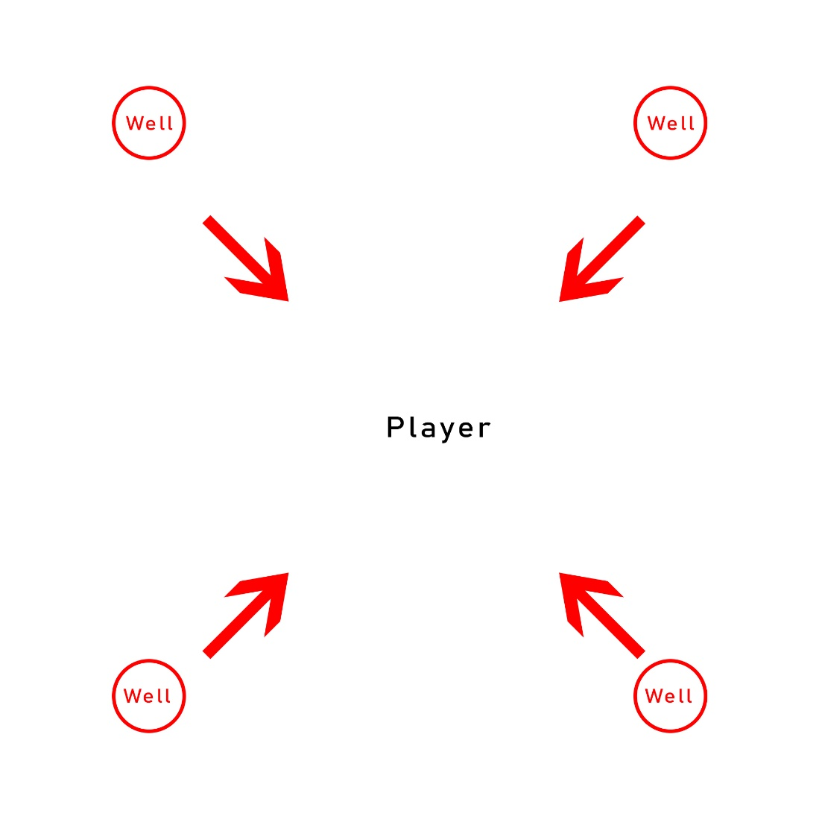

Runes
- Lightning Rod
  - Wheels are no longer spawned, instead, 4 lightning rods are spawned that deal 120% weapon damage as lightning to enemies per second within 15 yards. Only 4 can exist at a time. Element changes to Lightning.
- Spatial Control
  - Only one well is spawned and the wheel now spins around the well once before disappearing. The spin has a radius of 15 yards and knocks back enemies hit. Damage is increased to 500%. Element changes to arcane.
- Overflowing Power
  - Two wells are spawned in front of and behind the player relative to the cast location. One wheel will move between these two wells 4 times, and each time it touches a well its damage and size increase by 15%. Base damage is increased to 200%.
    - The wheel’s damage goes:
      - 230%
      - 265%
      - 305%
      - 350%
      - Total damage output if enemy is hit 4 times: 1150% damage.
- Fonts of Power
  - Spawns 8 wells in an octagonal pattern instead but damage is reduced to 100% per wheel and wells are spawned 35 yards away.
  - It looks like this:
  - 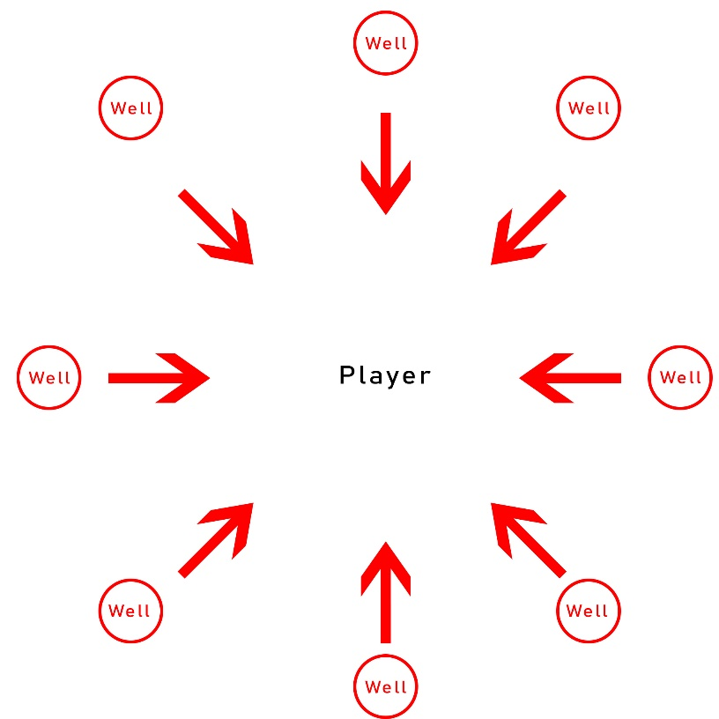
- Elemental Suction
  - Grants the wizard 5% increased armor per enemy hit for 7 seconds. Armor increase is capped at 75%. Element changes to cold.

Design Intentions/Goals
This new secondary spell offers the wizard new playstyle options and new builds to try out. The runes are intended to accomplish different goals, either support in the forms of a buff or cc, or pure damage for a damage dealing build. Roiling power can also be set to each element to allow use for any elemental build and use in Tal Rashas in any element slot or Firebirds.
The runes Overflowing Power and Fonts of Power are both intended for high damage output, but in slightly different ways to allow for different uses. Overflowing Power gives more raw damage but can be harder to land as the wheel needs to hit all 4 times to have greater damage output, but if it does, this rune will deal 350% more damage than Fonts of Power. However, Fonts of Power is a more reliable rune. The 8 wheels are easier to hit enemies with, especially larger targets like Rift Guardians and bosses. Fonts of Power will fit nicely into Firebird’s builds as it’s very easy to hit these wheels on lots of enemies at once.
Spatial Control and Elemental Suction are both intended as defensive options. Spatial control gives wizards a form of CC that is especially useful for channeling builds when combined with Etched Sigil. These can be placed around to control space and prevent enemies from reaching the wizard. Elemental suction is a straightforward defensive rune. A 75% armor buff is nothing small though so this can fit into many different builds.

Monk

Weighty Strike

Spell Type
Secondary

Cost
100 Spirit

Cooldown
None

Damage Type
Physical

Effect
Weighty Strike damages a single target for 900% of weapon damage. This technique has a unique attack speed cap of 1 per second. Any attack speed above this cap when the ability is cast is converted into extra damage at a rate 2% damage for 1% attack speed.

Runes
- One-Inch Punch
  - Weighty Strike now deals 1200% weapon damage.
- Piercing Force
  - Weighty Strike now deals an additional 700% weapon damage in a line behind the target. Range is 20 yards. Element is changed to fire.
- Shockwave
  - Enemies killed by Weighty Strike now explode dealing 50% of the damage dealt in a 15 yard radius.
- Concussive Punch
  - Weighty Strike deals double damage to enemies that are blinded or frozen.
    - This doubling is handled at the end of regular damage calculation.
- Balance of Power
  - Weighty Strike’s attack speed cap is now halved but the damage conversion rate for attack speed is doubled.

Design Intentions/Goals
This skill fits into a different kind of martial artist fantasy than what the Monk focuses on. The monk is a fast character, focusing on a lot of attack speed with combo abilities. Weighty Strike is instead extremely slow and falls into a fantasy of things like the One-Inch Punch. The animation is intended to be a deep breath in, and then a breath out while punching with a large shock wave coming from the punch. The skill also has an extremely high cost (100 spirit). Since the attack speed for this skill is capped at 1 it needs a high cost to force players to manage spirit in some way.
Since this is a Secondary skill it can benefit from the Sunwuko Set as well as much more broadly applied Inna’s set. This allows players to have a new experience with the Sunwuko set. Also, since this is a spirit spender, it can potentially be used with the Rabid Strike fist weapon to duplicate its cast.
One-Inch Punch is a straightforward damage increase rune. It provides a significant increase to the base damage of the skill, though it is not quite as much damage as the Balance of Power rune. It’s an easy, early rune.
Piercing Force and Shockwave are both AoE runes for this single target skill. Piercing Force provides a straightforward AoE to use that can hit a larger number of targets than Shockwave. However, Shockwave can deal significantly more damage than Piercing Force to a smaller number of targets. 50% of the damage dealt can be quite high. This rune doesn’t stand out too much on its own and is intended to be used with a legendary item that provides this rune.
Concussive Punch allows weighted strike to be used in a different way than most skills. It helps push the skill into the fantasy of combination techniques where the enemy is blinded first, and then damaged. Also, because of the way damage is calculated with this rune, the damage increase can be immense, as this would even double the damage of a crit.
Balance of Power double dips on Weighty Strike’s unique attack speed cap. It forces the skill to attack only once every 2 seconds. When combined with items like Flying Dragon or the Monk’s many attack speed increasing items and skills. This rune leans heavily into the fantasy of this skill.

Necromancer

Ossian Engineering

Spell Type
Secondary

Cost
50 Essence

Cooldown
None

Damage Type
Physical

Effect
Creates a gigantic fist of bone to smash enemies in front of itself. Deals 325% weapon damage to affected enemies in a 20 yard radius.

Runes
- Petrified Bone
  - Stuns enemies hit for 2 seconds.
- Cage of Flesh
  - Now creates a cage of flesh with a 15 yard radius. Spawns a corpse for each enemy that was hit.
    - Damage is dealt once to each enemy inside the cage.
- Voracious Creation
  - Creates a devouring maw at the cast location that lasts for 5 seconds and will draw in and consume nearby corpses. Once the duration has ended the maw explodes dealing 350% weapon damage in a 20 yard radius. Damage and size of the explosion are increased per corpse consumed up to 700% weapon damage in a 41 yard radius. Element changes to poison. Costs 5% of the necromancers health.
    - Each corpse provides 50% damage and 3 yards (up to 7 corpses can be consumed)
- Rathma’s Throne
  - Prevents movement and most spell casting for the necromancer but gives the Necromancer 70% damage reduction while active. Increases the damage of all the Necromancer’s pets while active by 100% and attack speed by 50%. Can be canceled by recasting the ability. The only spells that can be cast while active are:
    - Command Skeletons
    - Skeletal Mage
    - Command Golem
    - Army of the Dead
  - Counts as a channel and essence cost increase to 75.
- Xul’s Chariot
  - Creates a chariot of bone that is ridden by the necromancer from his pets. Travels forward following the player’s mouse for 5 seconds. Deals 275% weapon damage to enemies it passes through. Damage and speed are increased by 10% per pet consumed.
    - Pets consumed in this way trigger death effects such as the Mage’s Gift of Death rune.
    - The necromancer can take damage while this is active. It can be canceled early by casting other skills.

Design Intentions/Goals
Ossian Engineering is intended to fill a bunch of different roles for a necromancer, but it ultimately fulfills the fantasy of creating things from flesh and bone. Right now, it probably fills too many roles and needs to be shifted into a more directed skill, but I wanted to see how far I could push the necromancer archetype while also giving the necromancer a few new options for builds. The current design of this skill is also a little odd because there are certain legendary affixes I want to introduce that would only affect certain runes of this skill which could be confusing for players.
Petrified bone is a straightforward rune. Providing a reliable stun for the necromancer can combo with Krysbin’s Sentence and give some more options for controlling enemy packs.
Cage of Flesh provides another way that the necromancer can get corpses to fuel corpse skills and builds. The rune is intentionally spammable, as this will allow the player to really go crazy with corpse skills and have a great time. However, this does run the risk of completely breaking builds like Trag’oul’s Corpse Lance builds. If this does turn out to be the case the best way to bring that back into line would be to only allow an enemy to provide a corpse once when hit by this rune.
Voracious Creation is a high damage rune for the necromancer to choose. It consumes both corpses and health. This is fairly limiting as the player will need to bring something to provide corpses, like the Golem, but it can also be used with the Trag’oul’s set to increase its damage. While there is no cooldown on this skill there is a ‘soft cooldown’. The skill requires corpses to use, and is significantly less effective without corpses.
Rathma’s Throne leans into the commander aspect of the necromancer. By preventing spellcasting and only allowing pet skills the player can truly feel like the commander of an army. The 70% damage reduction is provided to allow the player to actually stand still and be able to survive. There is also no cooldown associated with this skill as the player will likely need to move around from point to point depending on what enemies they are fighting.
Xul’s Chariot is a speedfarming rune. It will likely not be very good for pushing Grater Rifts but it provides a lot of speed to the player and can damage enemies while moving. It also plays heavily into the fantasy of reconstructing your skeletons into something more dangerous.

